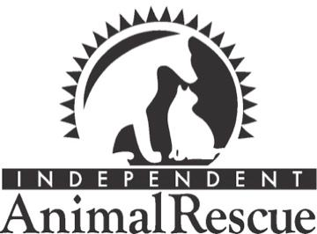
Independent Animal Rescue
2020-2021 Sponsorship Tiers

Year-Round Sponsorship Options

Gold Level Sponsor - $5,000/year
- Opportunities to collaborate with IAR to create customer-facing content focused on your company’s support of animal welfare and your partnership with IAR.
- Opportunities to collaborate with IAR on social media.
- Name, logo, and link to your website on IAR’s website for 12 months.
- Name, logo, and link to your website in our monthly email newsletter for 12 months.
- Recognition as a sponsor of IAR on our social media channels.

Silver Level Sponsor - $2,500/year
- Name/logo on IAR’s website for 12 months
- Name/logo in our monthly email newsletter for 12 months
- Recognition as a sponsor of IAR on our social media channels

Bronze Level Sponsor - $1,000/year
- Name/logo on IAR’s website for 6 months

Independent Animal Rescue is a registered 501(c)(3) nonprofit organization: EIN NUMBER: 56-1951483

